**DEMOGRAPHICS OF THE CATCHMENT POPULATION**

The SCC catchment area includes 82 counties in Missouri (40) and Illinois (42) within

~100-mile radius of SCC. 87% of new patients (2018) reside in the catchment.

The racial distribution of the catchment is 79.5% non-Hispanic White and 20.5%

minority (13.7% African American, 2% Asian, and 4.8% multiracial or other minority).

2.7% of the catchment population identifies as Hispanic/Latino ethnicity.

15% of the catchment reside in a rural area.

29% of the catchment reside in a medically underserved area (MUA).

*Source: 2018 American Community Survey (https://factfinder.census.gov/faces/nav/jsf/pages/community_facts.xhtml) Retrieved 4/18/19*

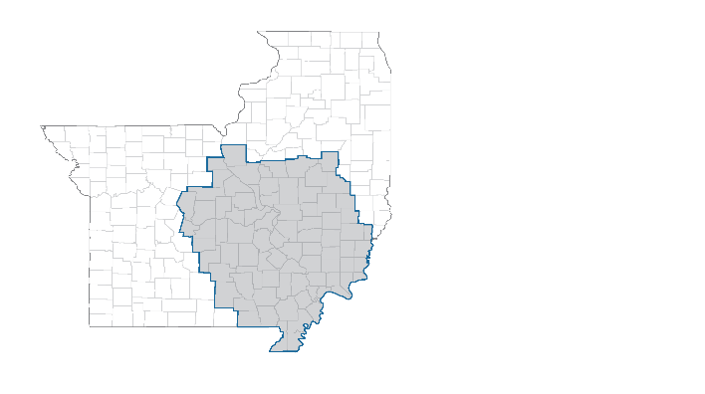

This report intends to provide a description of cancer in the Siteman Cancer Center (SCC) catchment, as well as the demographics of cancer patients treated at SCC. The Research Program Reports will also provide current recruitment numbers for Hematopoietic Development and Malignancy Program (HDMP) clinical trials, including demographics of patients enrolled on trial. Minority is defined as self-identified race other than non-Hispanic white and includes Hispanic ethnicity. Unknown race or ethnicity is not considered minority. Rural is defined as RUCA ≥7.

**DEMOGRAPHICS OF THE SCC PATIENT POPULATION (ALL SITES)**

The racial distribution of the SCC patient population in 2018 is 83.1%% non-Hispanic White and 16.9% minority (12.4% African American, 1.4% Asian, and 3.1% multiracial or other minority).

0.3% of the SCC patient population identifies as Hispanic/Latino ethnicity.

13% of SCC patients reside in a rural zip code.

27% of SCC patients reside in a medically underserved area (MUA).

Of note, 48.5% of rural patients live in a MUA.

*Source: 01/2018 – 12/2018 newly diagnosed cancer patients at Siteman Cancer Center*



**DEMOGRAPHICS OF SCC HEMATOLOGIC CANCER PATIENTS**

In 2017, SCC reported a total of 868 new hematologic and lymphoid cancer cases across all sites. Of these patients, a total of 87.3% were White (n=758), 11.2% Black (n=97), and 1.5%% (n=13) Other Minorities. This percentage of minority patients seen at SCC is used to define the minority accrual goal for HDMP.

*Source: 01/2017 – 12/2017 cancer patients from SCC Tumor Registry (SCC, BJC-WC, BJC-SP)*

**The minority accrual goal for HDMP clinical trials is 12.7%.**

**CANCER BURDEN IN THE CATCHMENT**

**Table 1** presents county-level age-adjusted incidence and mortality rates of Leukemia and Non-Hodgkin Lymphoma from 2012-2016 by race for Missouri, Illinois, and our catchment counties.

**Table 1. Leukemia and Non-Hodgkin Lymphoma Incidence and Mortality (2012-2016)**

|  |  |  |  |  |  |  |  |  |  |  |  |  |
| --- | --- | --- | --- | --- | --- | --- | --- | --- | --- | --- | --- | --- |
|  | **Leukemia** | | | | | | **Non-Hodgkin Lymphoma** | | | | | |
|  | **Incidence**  **(AAR per 100k)** | | | **Mortality**  **(AAR per 100k)** | | | **Incidence**  **(AAR per 100k)** | | | **Mortality**  **(AAR per 100k)** | | |
|  | **Total** | **Black** | **White** | **Total** | **Black** | **White** | **Total** | **Black** | **White** | **Total** | **Black** | **White** |
| Catchment | 18.3 | 10.7 | 18.9 | 7.3 | 6.3 | 7.4 | 24.6 | 13.7 | 25.7 | 6.0 | 4.0 | 6.2 |
| Missouri | 16.2 | 10.4 | 17.3 | 7.1 | 6.5 | 7.2 | 22.2 | 13.4 | 23.8 | 5.4 | 4.1 | 5.5 |
| Illinois | 14.7 | 10.4 | 15.9 | 6.8 | 6.2 | 7.1 | 21.6 | 12.5 | 23.9 | 5.7 | 3.6 | 6.0 |
| U.S. | 15.7 | 9.5 | 17.2 | 6.5 | 5.5 | 6.8 | 21.7 | 12.8 | 23.8 | 5.6 | 4.1 | 5.9 |

*Source: State Cancer Profiles 2012-2016 (https://statecancerprofiles.cancer.gov), Average Annual Counts Retrieved 8/12/19*

**Figures 1-4** provide a comparison of the catchment to national rates for cancer incidence and mortality.

***Hematologic cancer incidence and mortality is higher in the catchment compared to the national rates.***

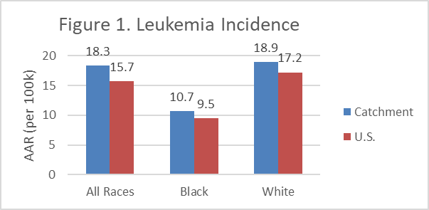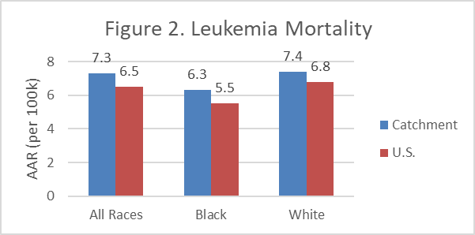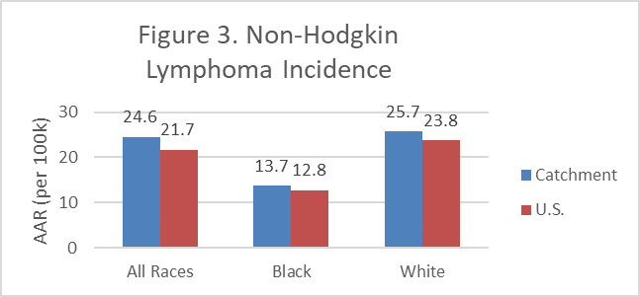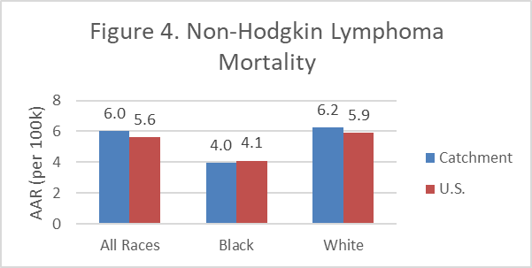

*Source: State Cancer Profiles 2012-2016 (https://statecancerprofiles.cancer.gov), Retrieved 8/12/19*

**CANCER BURDEN AT SCC**

**Table 2** presents the number of hematopoietic and lymphoid cancer cases at SCC by race for 2013-2017 (*Source: Tumor Registry Data - BJH/BJWC/BJSP*). **In the most recent 5-year period at SCC, 87.6% of patients were White, 10.7% were Black, and 1.7% were other minorities.**

**Table 2. SCC Tumor Registry Cancer Incidence (2013-2017)**

|  |  |  |  |  |  |  |  |  |  |  |  |  |
| --- | --- | --- | --- | --- | --- | --- | --- | --- | --- | --- | --- | --- |
|  | 2013 | | 2014 | | 2015 | | 2016 | | 2017 | | 5-year total | |
|  | # | % | # | % | # | % | # | % | # | % | # | % |
| Black | 621 | 17.2 | 627 | 16.7 | 596 | 15.7 | 619 | 16.3 | 627 | 16.2 | 3090 | 16.4 |
| Other Minority | 55 | 1.5 | 64 | 1.7 | 61 | 1.6 | 71 | 1.9 | 76 | 2.0 | 327 | 1.8 |
| Total Minority | 676 | 18.7 | 691 | 18.4 | 657 | 17.3 | 690 | 18.2 | 703 | 18.2 | 3417 | 18.2 |
| White | 2941 | 81.3 | 3069 | 81.6 | 3131 | 82.7 | 3099 | 81.8 | 3159 | 81.8 | 15399 | 81.8 |
|  | 3617 |  | 3760 |  | 3788 |  | 3789 |  | 3862 |  | 18816 |  |

*Source: 2013 – 2017 cancer patients from SCC Tumor Registry (SCC, BJC-WC, BJC-SP)*

**Figure 5** graphs the last 5 years of Tumor Registy Data to show the trends in % minority.

**Pooled 5-year data (2013-2017) for all hematologic cancers treated at SCC shows that 12.4% of SCC newly diagnosed cancer patients are minority.**

**HEMATOPOIETIC DEVELOPMENT AND MALIGNANCY PROGRAM CLINICAL TRIAL ACCRUALS**

**Table 3** presents the demographics of patients enrolled in HDMP clinical. The goal for percent minority enrollment is 12.7%, which is based on the most recent (2018) SCC minority patient population.

***In 2018 AND 2019, HDMP minority accrual exceeded the goal. The 2019 minority accruals are currently 15.1%.***

**Table 3. Minority Accruals for HDMP (2015-2019)**

|  |  |  |  |  |  |  |  |  |  |  |
| --- | --- | --- | --- | --- | --- | --- | --- | --- | --- | --- |
|  | 2015 | | 2016 | | 2017 | | 2018 | | 2019 | |
|  | # | % | # | % | # | % | # | % | # | % |
| Am. Indian / AK native | 4 | 0% | 5 | 0% | 4 | 0% | 0 | 0% | 3 | 0.2% |
| Asian / HI / Pac. Isle. | 18 | 1.0% | 14 | 0.9% | 10 | 0.6% | 10 | 0.9% | 14 | 1.2% |
| Black | 176 | 9.9% | 141 | 8.6% | 134 | 8.5% | 160 | 9.9% | 133 | 11.0% |
| Other (Minority) | 8 | 0.5% | 8 | 0.5% | 4 | 0.3% | 23 | 1.4% | 12 | 1% |
| Hispanic | 27 | 1.5% | 20 | 1.2% | 23 | 1.5% | 20 | 1.3% | 21 | 1.7% |
| **All Minorities** | **233** | **13.1%** | **188** | **11.4%** | **175** | **11.1%** | **213** | **13.3%** | **183** | **15.1%** |
| White | 1553 | 86.9% | 1458 | 88.6% | 1400 | 88.9% | 1394 | 86.7% | 1029 | 84.9% |
| Total | 1786 |  | 1646 |  | 1575 |  | 1607 |  | 1212 |  |

*Source: OnCore Accruals Report Retrieved 09/04/19*

While total clinical trial accruals are presented in Table 3, **Table 4** presents minority accrual numbers for each type of HDMP trial enrolling patients between 2015 and August 31, 2019. HDMP also utilizes summary accruals, meaning batched datasets are uploaded to ensure anonymity of the patients participating. The total number of accruals is therefore higher than the numbers reported in Table 4 because many summary patient records exclude demographic data and cannot be included in minority calculations. ***In 2018, minority accrual numbers for All Trial Types exceeded the goal set by % Minority population at SCC***

**Table 4. Minority Accrual of HDMP Trials, Sorted by Trial Type**

|  |  |  |  |  |  |  |  |  |  |  |
| --- | --- | --- | --- | --- | --- | --- | --- | --- | --- | --- |
|  | 2015 | | 2016 | | 2017 | | 2018 | | 2019 | |
|  | # | % | # | % | # | % | # | % | # | % |
| Observational | 20  158 | 12.7% | 57  418 | 13.6% | 64  467 | 13.7% | 29  252 | 11.5% | 20  196 | 10.2% |
| Other | 70  519 | 13.5% | 20  203 | 9.9% | 17  144 | 11.8% | 20  113 | 17.7% | 27  137 | 19.7% |
| Ancillary/Correlative | 65  487 | 13.3% | 64  575 | 11.1% | 62  557 | 11.1% | 89  662 | 13.4% | 89  536 | 16.6% |
| Interventional | 75  637 | 11.8% | 71  552 | 12.9% | 61  594 | 10.3% | 75  485 | 15.5% | 47  344 | 13.7% |
| Treatment | 72  617 | 11.7% | 68  548 | 12.4% | 59  585 | 10.1% | 61  465 | 13.1% | 43  300 | 14.3% |
| All Trial Types | 302  2418 | 12.5% | 280  2296 | 12.2% | 263  2347 | 11.2% | 213  1512 | 14.1% | 183  1213 | 15.1% |

*Source: OnCore Accruals Report Retrieved 09/04/19*

**HEMATOPOIETIC DEVELOPMENT AND MALIGNANCY PROGRAM CLINICAL TRIAL ACCRUALS**

**Table 5** presents a summary directly comparing the Catchment population, SCC patient population, and HDMP Clinical Trial accruals.

**Table 5. Summary of HDMP Accruals Compared to the Catchment and SCC Patient Populations**

|  |  |  |  |  |  |  |
| --- | --- | --- | --- | --- | --- | --- |
|  | Catchment | SCC Patients | HDMP  All Trials | | HDMP  Treatment Trials | |
|  | 2018 | 2018 | 2018 | 2019 | 2018 | 2019 |
| Catchment | -- | 87% | 75.4% | 74.4% | 68.2% | 69.0% |
| Rural | 15% | 13% | 14.4% | 15.3% | 13.5% | 12.7% |
| MUA | 29% | 27% | 21.2% | 22.2% | 21.1% | 19.7% |
| Minority | 20.5% | 16.9% | 13.3% | 15.1% | 13.1% | 14.3% |
| Black | 13.7% | 12.4% | 9.9% | 11.0% | 9.9% | 9.7% |
| Asian | 2.0% | 1.4% | 0.9% | 1.2% | 0.4% | 0.7% |
| Other Race | 2.7% | 3.1% | 1.4% | 1.2% | 1.3% | 2.3% |
| Hispanic | 4.8% | 0.3% | 1.3% | 1.7% | 1.7% | 2.7% |
| Non-Hispanic White | 79.5% | 83.1% | 88.9% | 84.9% | 86.9% | 85.7% |

**Table 6** presents current minority accrual numbers for all Leukemia SPORE trials. The total % minority accruals is 9.0% across Leukemia SPORE trials, but the goal for % minority may vary for each trial based on total number of patients with specific disease diagnoses.

**Table 6. Minority Accrual of Leukemia SPORE Trials**

