**DEMOGRAPHICS OF THE CATCHMENT POPULATION**

The SCC catchment area includes 82 counties in Missouri (40) and Illinois (42) within

~100-mile radius of SCC. 87% of new patients (2018) reside in the catchment.

The racial distribution of the catchment is 79.5% non-Hispanic White and 20.5%

minority (13.7% African American, 2% Asian, and 4.8% multiracial or other minority).

2.7% of the catchment population identifies as Hispanic/Latino ethnicity.

15% of the catchment reside in a rural area.

29% of the catchment reside in a medically underserved area (MUA).

*Source: 2018 American Community Survey (https://factfinder.census.gov/faces/nav/jsf/pages/community_facts.xhtml) Retrieved 4/18/19*

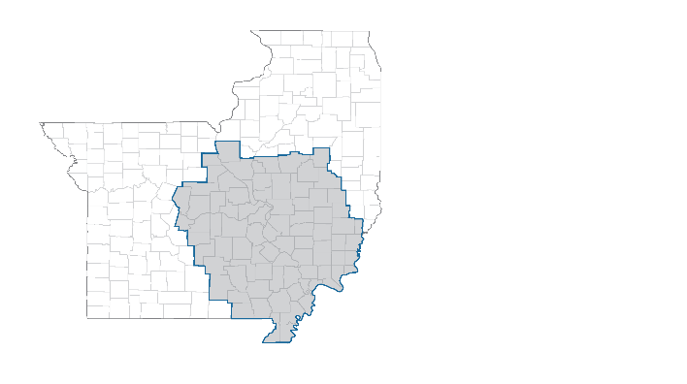

This report intends to provide a description of breast cancer in the Siteman Cancer Center (SCC) catchment, as well as the demographics of breast cancer patients treated at SCC. The Research Program Reports will also provide current recruitment numbers for Breast Cancer Research Program (BCRP) clinical trials, including demographics of patients enrolled on trial. Minority is defined as self-identified race other than non-Hispanic white and includes Hispanic ethnicity. Unknown race or ethnicity is not considered minority. Rural is defined as RUCA ≥7.

**DEMOGRAPHICS OF THE SCC PATIENT POPULATION (ALL SITES)**

The racial distribution of the SCC patient population in 2018 is 83.1%% non-Hispanic White and 16.9% minority (12.4% African American, 1.4% Asian, and 3.1% multiracial or other minority).

0.3% of the SCC patient population identifies as Hispanic/Latino ethnicity.

13% of SCC patients reside in a rural zip code.

27% of SCC patients reside in a medically underserved area (MUA).

Of note, 48.5% of rural patients live in a MUA.

*Source: 01/2018 – 12/2018 newly diagnosed cancer patients at Siteman Cancer Center*



**DEMOGRAPHICS OF SCC BREAST CANCER PATIENTS**

In 2017, SCC reported a total of 1214 new breast cancers. Of these patients, a total of 81.2% were White (n=986), 16.2% Black (n=197), and 2.6% (n=31) Other Minorities.

*Source: 01/2017 – 12/2017 breast cancer patients from SCC Tumor Registry (SCC, BJC-WC, BJC-SP)*

**The minority accrual goal for BCRP clinical trials is 18.8%.**

**BREAST CANCER BURDEN IN THE CATCHMENT**

**Table 1** presents county-level age-adjusted incidence and mortality rates from 2012-2016 by race for Missouri, Illinois, and our catchment counties.

**Table 1. Breast Cancer Incidence and Mortality (2012-2016)**

|  |  |  |  |  |  |  |  |  |  |
| --- | --- | --- | --- | --- | --- | --- | --- | --- | --- |
|  | **Incidence (All Stages)**  **(AAR per 100k)** | | | **Incidence (Late Stage)**  **(AAR per 100k)** | | | **Mortality**  **(AAR per 100k)** | | |
|  | **Total** | **Black** | **White** | **Total** | **Black** | **White** | **Total** | **Black** | **White** |
| Catchment | 124.4 | 125.4 | 125.1 | 46.1 | 52.2 | 45.8 | 23.3 | 31.4 | 23.4 |
| Missouri | 129.2 | 133.1 | 128.7 | 45.8 | 57.8 | 44.4 | 21.7 | 31.1 | 20.8 |
| Illinois | 131.9 | 133.5 | 133.1 | 45.9 | 55.1 | 44.9 | 21.8 | 30.7 | 20.9 |
| U.S. | 125.2 | 124.0 | 126.1 | 42.3 | 51.0 | 41.4 | 20.6 | 28.1 | 20.1 |

*Source: State Cancer Profiles 2012-2016 (https://statecancerprofiles.cancer.gov), Average Annual Counts Retrieved 8/12/19*

**Figures 1-3** provide a comparison of the catchment to national rates for breast cancer incidence, late stage incidence, and mortality.

***Within the catchment, breast cancer incidence is comparable for Black and White women. However, Black women have higher incidence of late stage diagnoses and mortality. Mortality is higher in the catchment compared to the national rates.***

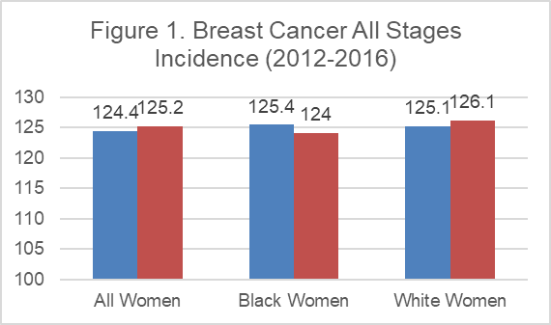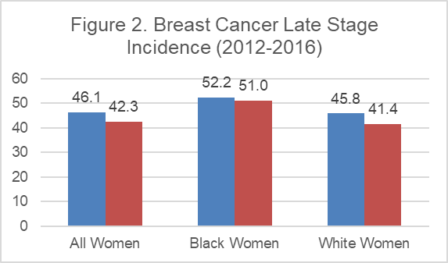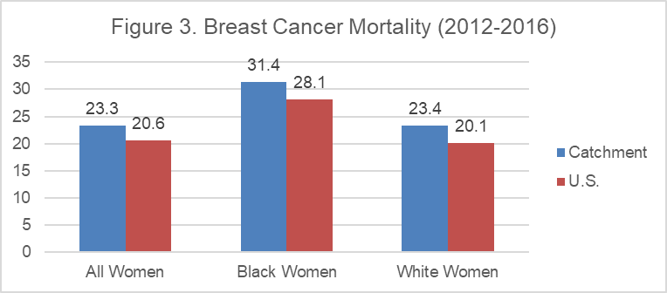

*Source: State Cancer Profiles 2012-2016 (https://statecancerprofiles.cancer.gov), Retrieved 8/12/19*

**Table 2** presents the number of breast cancer by race for 2013-2017. **In the most recent 5-year period at SCC, 79.9% of patients were White, 17.4% were Black, and 2.7% were other minorities.**

**Table 2. SCC Breast Cancer Incidence (2013-2017)**

|  |  |  |  |  |  |  |  |  |  |  |  |  |
| --- | --- | --- | --- | --- | --- | --- | --- | --- | --- | --- | --- | --- |
|  | 2013 | | 2014 | | 2015 | | 2016 | | 2017 | | 5-year total | |
|  | # | % | # | % | # | % | # | % | # | % | # | % |
| Black | 199 | 19.5 | 206 | 18.3 | 173 | 15.3 | 205 | 18.0 | 197 | 16.2 | 980 | 17.4 |
| Other Minority | 20 | 2.0 | 28 | 2.5 | 35 | 3.1 | 36 | 3.2 | 31 | 2.6% | 150 | 2.7 |
| Total Minority | 219 | 21.4 | 234 | 20.8 | 208 | 18.4 | 241 | 21.2 | 228 | 18.8 | 1130 | 20.1 |
| White | 804 | 78.6 | 890 | 79.2 | 925 | 81.6 | 896 | 78.8 | 986 | 81.2 | 4501 | 79.9 |
|  | 1023 |  | 1124 |  | 1133 |  | 1137 |  |  |  | 5631 |  |

*Source: 2013 – 2017 breast cancer patients from SCC Tumor Registry (SCC, BJC-WC, BJC-SP)*

**Figure 5** directly compares the data for the catchment against the Tumor Registry Data to show the trends in late stage at diagnosis. **A higher proportion of Black patients are diagnosed at late stage compared to White patients, and SCC patients are diagnosed at later stage more frequently than the percentages of late stage at diagnosis for the entire catchment.**

**BREAST CANCER BURDEN AT SCC**

**Figure 4** graphs the last 5 years of Tumor Registy Data to show the trends in % minority.

**Pooled 5-year data (2013-2017) for all breast cancers treated at SCC shows that 20.1% of SCC newly diagnosed breast cancer patients are minority.**

**BREAST CANCER RESEARCH PROGRAM CLINICAL TRIAL ACCRUALS**

**Table 3** presents the demographics of patients enrolled in BCRP clinical. The goal for percent minority enrollment is 18.8%, which is based on the most recent (2017) SCC Tumor Registry Data.

***In 2018, BCRP minority accrual exceeded the goal. The 2019 minority accruals are currently 17.8%.***

**Table 3. Minority Accruals for BCRP (2015-2019)**

|  |  |  |  |  |  |  |  |  |  |  |
| --- | --- | --- | --- | --- | --- | --- | --- | --- | --- | --- |
|  | 2015 | | 2016 | | 2017 | | 2018 | | 2019 | |
|  | # | % | # | % | # | % | # | % | # | % |
| Am. Indian / AK native | 4 | 0.4% | 2 | 0.2% | 2 | 0.2% | 1 | 0.1% | 1 | 0.2% |
| Asian / HI / Pac. Isle. | 16 | 1.6% | 14 | 1.1% | 17 | 1.7% | 16 | 1.3% | 5 | 0.9% |
| Black | 364 | 36.0% | 484 | 37.8% | 285 | 28.1% | 240 | 19.3% | 79 | 14.3% |
| Other (Minority) | 12 | 1.2% | 12 | 0.9% | 13 | 1.3% | 19 | 1.5% | 8 | 1.5% |
| Hispanic | 40 | 4.0% | 33 | 2.6% | 16 | 1.6% | 12 | 1.0% | 5 | 0.9% |
| **All Minorities** | **436** | **43.2%** | **545** | **42.6%** | **333** | **32.8%** | **288** | **23.2%** | **98** | **17.8%** |
| White | 574 | 56.8% | 735 | 57.4% | 682 | 67.2% | 955 | 76.8% | 453 | 82.2% |
| Total | 1010 |  | 1280 |  | 1015 |  | 1243 |  |  |  |

*Source: OnCore Accruals Report Retrieved 09/04/19*

**Table 4** presents minority accrual numbers for each type of BCRP trial enrolling patients between 2015 and August 2019. BCRP includes summary accruals, comprised of batched datasets that may lack demographic information. The total number of accruals is therefore higher than the numbers reported in Table 4 because many summary patient records exclude demographic data and cannot be included in minority calculations.

***In 2018, minority accrual numbers for Interventional Treatment Trials exceeded the goal. Currently for 2019, BCRP accruals are 18.0%.***

**Table 4. Minority Accrual of BCRP Trials, Sorted by Trial Type**

|  |  |  |  |  |  |  |  |  |  |  |
| --- | --- | --- | --- | --- | --- | --- | --- | --- | --- | --- |
|  | 2015 | | 2016 | | 2017 | | 2018 | | 2019 | |
|  | # | % | # | % | # | % | # | % | # | % |
| Observational | 6  56 | 12.5% | 7  58 | 12.1% | 54  205 | 26.3% | 153  463 | 33.0% | 8  50 | 16.0% |
| Other | 360 582 | 61.9% | 348  487 | 71.5% | 169  254 | 66.5% | 13  71 | 18.3% | 15  117 | 12.8% |
| Ancillary/Correlative | 31  150 | 20.7% | 143 440 | 32.5% | 21  58 | 36.2% | 7  35 | 20.0% | 12  42 | 28.6% |
| Interventional | 37  224 | 16.5% | 47  295 | 15.9% | 89  484 | 18.4% | 115  674 | 17.1% | 63  342 | 18.4% |
| Treatment | 29  171 | 17.0% | 39  230 | 17.0% | 44  286 | 15.4% | 37  175 | 21.1% | 22  122 | 18.0% |
| All Trial Types | 435  1012 | 43.0% | 531  1280 | 41.5% | 333  1001 | 33.3% | 288  1243 | 23.2% | 98  551 | 17.8% |

*Source: OnCore Accruals Report Retrieved 09/04/19*

**Table 5** presents a summary directly comparing the Catchment population, SCC patient population, and BCRP Clinical Trial accruals.

**Table 5. Summary of BCRP Accruals Compared to the Catchment and SCC Patient Populations**

|  |  |  |  |  |  |  |
| --- | --- | --- | --- | --- | --- | --- |
|  | Catchment | SCC Patients | BCRP  All Trials | | BCRP  Treatment Trials | |
|  | 2018 | 2018 | 2018 | 2019 | 2018 | 2019 |
| Catchment | -- | 87% | 79.1% | 90.7% | 84% | 88.5% |
| Rural | 15% | 13% | 6.7% | 9.1% | 10.9% | 9.0% |
| MUA | 29% | 27% | 16.6% | 17.2% | 18.9% | 17.2% |
| Minority | 20.5% | 16.9% | 23.2% | 17.8% | 21.1% | 18.0% |
| Black | 13.7% | 12.4% | 19.3% | 14.3% | 17.7% | 14.8% |
| Asian | 2.0% | 1.4% | 1.3% | 0.9% | 1.1% | 1.6% |
| Other Race | 2.7% | 3.1% | 1.6% | 1.7% | 1.7% | 0% |
| Hispanic | 4.8% | 0.3% | 1.0% | 0.9% | 0.6% | 1.6% |
| Non-Hispanic White | 79.5% | 83.1% | 76.8% | 82.2% | 78.9% | 82% |